COT4210 Discrete Structures – Exam 1

Spring 2023

1. (10) *En* is the language that contains all and only strings that, in turn, contain nothing but the letter “**e**” some integer multiple of *n* times:

*En* = {**e***k* | *k* is a multiple of *n*}.

Show that this languageis regular for any positive integer *n*. *(Hint:* ***You do not need induction****.)*

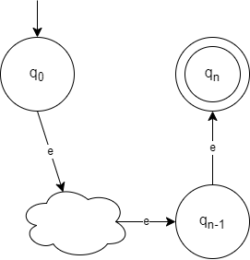

The above shows an NFA that proves language L where

$Q=\{q_{0}, q_{1}, q_{k}\}$

$F=\left\{q_{k}\right\}$

$d\left(q_{0},e\right)=\{q_{1}\}$

* $d\left(q_{i},e\right)=\left\{q_{i+1}\right\}$ for all $i<k$

$d\left(q_{k},e\right)=∅$

1. (15) Let *L* be the language over {**a**, **b**, **c**} accepting all strings so that:
   * 1. No **b**’s occur before the first **c**.
     2. No **a**’s occur after the first **c**.
     3. The last symbol of the string is **b**.
     4. Each **b** that is *not* the last symbol is immediately followed by at least two **c**’s.

Choose any constructive method you wish, and demonstrate that *L* is regular. *You do not need an inductive proof, but you should explain how your construction accounts for each rule.*

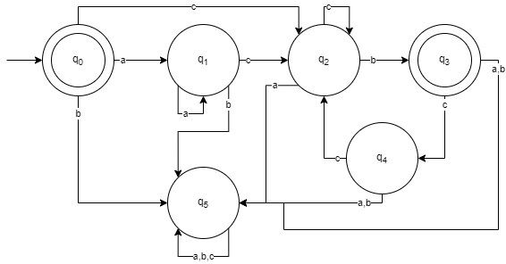

The graph above shows a DFA that proves language L

* An empty string is accepted so $q_{0}$ is a final state.
* There can’t be any b’s before the first c so $q_{0}$ and $q_{1}$ have a b input that leads to a dead end.
* There can’t be any a’s after the first c so all states after $q_{1}$ have an a input that leads to a dead end.
* The last symbol must be b so $q_{3}$ is also a final state.
* Each b that is not the last symbol is immediately followed by at least two c’s, so $q_{3}$ has a c input that leads to $q_{4}$ which has a c input that leads to $q_{2}$ and both $q_{3}$ and $q_{4}$ have a and b inputs that lead to a dead end which means b is always the final symbol.
* $q_{5}$ is a dead end so every input loops back into itself, if you’ve entered $q_{5}$ then the string is not accepted.

1. (15) A homomorphism on an alphabet is simply a function that gives a string for each symbol in that alphabet – for example, a homomorphism *h* on the binary alphabet might be defined so that *h*(**0**) = **ba** and *h*(**1**) = **edc**.

Homomorphisms can be extended to strings and languages in the straightforward way:

* + If *s* = *s*1*s*2*s*3…*sn* then *h*(*s*) = *h*(*s*1) *h*(*s*2) *h*(*s*3)… *h*(*sn*).
  + If *L* is a language then *h*(*L*) = { *h*(*s*) | *s* is in *L* }.

**Show that the class of regular languages is closed under homomorphism** – that is, that for any regular language *L*, and any homomorphism *h* on its alphabet, *h*(*L*) defined as above is regular. *HINT: If your proof is very long at all, you are doing more than you need to.*

If a homomorphism can be defined as where $L$ is a regular language, then its homomorphism is $h\left(L\right)=\left\{h(s) \right|s is in L\}$. We can create a general NFA that represents each $h(s)$ in $h(L)$ where $s=s_{1}{s_{2}}_{s_{3}}…s_{n}$ so that each transition concatenates a part of the string $h(s_{i})$

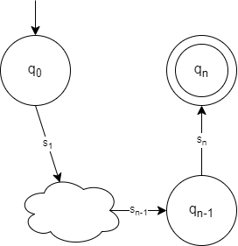

$Q=\{q_{0}, q_{1}, q_{n}\}$

$F=\left\{q_{n}\right\}$

$d\left(q_{0},s_{1}\right)=\{q_{1}\}$

* $d\left(q_{i},s_{i}\right)=\left\{q_{i+1}\right\}$ for all $i≤n$

1. (10) Comments in certain types of computer programming languages appear between starting and ending strings such as **<#** and **#>**.
   * + A comment must begin with **<#** and end with **#>**.
     + A comment may not contain **#>** inside the comment.
     + A comment’s starting and ending strings must be separate: **<##>** is a comment, **<#>** is not.
     + For simplicity, assume that the alphabet is  = {**a**, **b**, **<, >**, **#**}.

Give a regular expression that accepts comments.

Resulting regular expression: <#(#|(a|b|<)*)*#>

1. (15) Let Σ = {𝑎, 𝑏, #} and *L* = { *w* | *w* can be written as *t#s#t*R with 𝑠, 𝑡 ∈ {𝑎, 𝑏}∗}. Show that *L* is not regular.

Assume this language is regular with p as the pumping length and $s = t^{p}\#s^{p}{\#(t^{R})}^{p}$

* Then $s=xyz$ with $xy^{i}z$ in p for all nonnegative integers $i$, with $\left|y\right|>0$ and $\left|xy\right|≤p$
* Since $\left|xy\right|≤p$, x and y must be entirely in function $t^{p}$ with the remaining within z
* $xyyz$ will only change $t$ and not $t^{R}$
* Since $t^{R}$ will no longer equal the reverse of $t$, the language will be violated and therefore by contradiction the language is not regular.

1. (15) Using the procedure demonstrated in class and in the textbook, convert this NFA to a DFA.

a, d,

𝜀

b, d,

𝜀

c, d

a,b

c, d

*q*

2

*q*

1

*q*

3

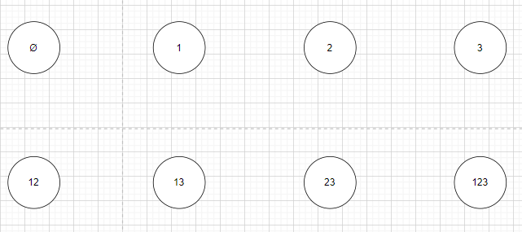

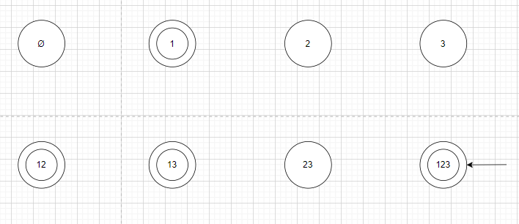

1. (5) Reduce the DFA resulting from problem 6.

1. (15) Convert this DFA to a regular expression using a GNFA.

a, b b, d

a

, c b, c

a, d

c, d

*q*

2

*q*

1

*q*

3

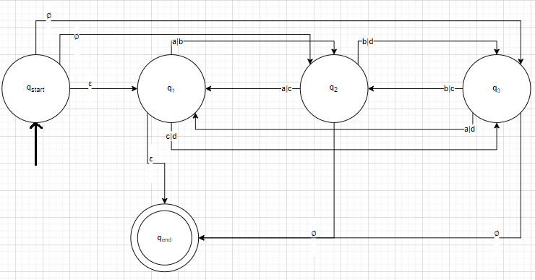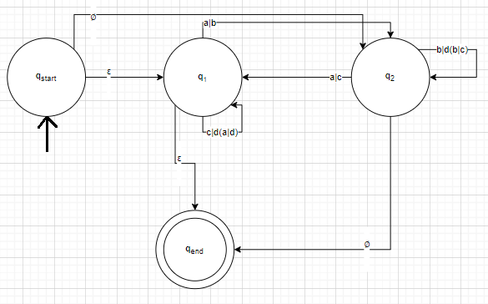

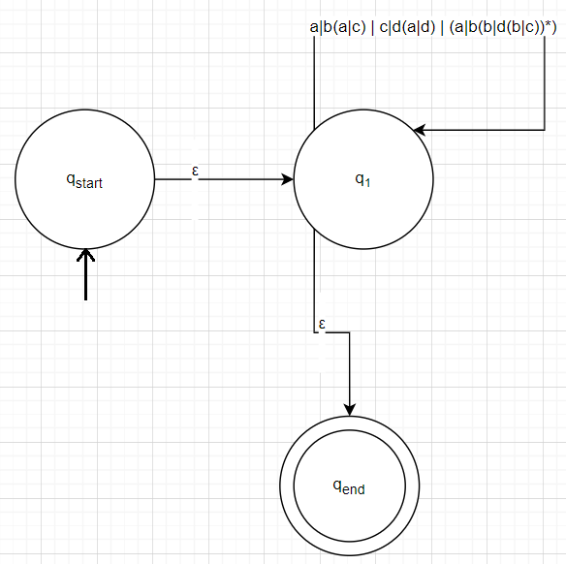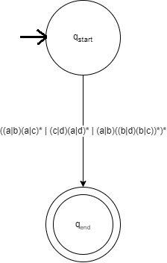

Resulting regular expression: ((a|b)(a|c)* | (c|d)(a|d)* | (a|b)((b|d)(b|c))*)*